**Comparing spatial prioritization methods for biodiversity conservation and ecosystem service supply in Europe**

**Joona Lehtomäki1\***, **Luigi Maiorano2** and **Peter verburg1**

1 Environmental Geography Group, Department of Earth Sciences, De Boelelaan 1105, 1081 HV Amsterdam, Vrije Universiteit Amsterdam, the Netherlands.

2 XXX

* Corresponding author

**Contact:** j.lehtomaki@vu.nl, tel. +31-20-59-87294  
 ORCID: 0000-0002-7891-0843

XXX XXX

peter.verburg@vu.nl, tel. +31-20-59-83594

**Running title:** Spatial prioritization comparison

**Keywords:** spatial prioritization; ecosystem services; biodiversity conservation; Zonation; optimization; environmental decision-making

**Manuscript version:** 0.7.1

**Manuscript statistics:** 261 words (abstract)  
 6331 words (main body)  
 67 references  
 6+3 figures  
 1+1 tables

**Abstract:**

Spatial identification of areas important both for biodiversity and the supply of ecosystem services (ESs) is an important part of operational decision-support for planning land-use and conservation management actions. Multiple methodological frameworks, such as multi-criteria decision making and spatial conservation prioritization, exist for spatial decision-support, but the degree to which they are applicable both to biodiversity conservation and ES still needs to be established. We compare three methods widely used in spatial conservation prioritization (rarity-weighted richness, Zonation and integer linear programming) to assess their suitability for spatial prioritization integrating both biodiversity and ESs. With each method, we run a spatial prioritization analysis for 763 European tetrapod species and for 9 ESs separately and together while using population density as a proxy for a cost of the solution. We then characterize the spatial similarity and performance of 1) the methods used and 2) for biodiversity and ESs respectively. We show that while all methods produce similar results in terms of average performance, the spatial pattern of especially the high priority rank varies a great deal. With all methods, the distribution of priority areas for biodiversity is bimodal within Europe with high-priority areas both in the north and south. For ESs, Central Europe is the highest priority region. Selecting top priority areas based only on biodiversity data can lead the 60% loss of performance in terms of the ESs covered, and 76% vice versa. When selecting a method for spatial prioritization of both biodiversity and ESs, it is important to consider the objectives of prioritization and what the data used is actually representing.

# Introduction

Management decisions concerning the future of biodiversity increasingly need to account for both biodiversity and ecosystem services (ESs) {Formatting Citation}(Cimon-Morin et al., 2013; Cordingley et al., 2016; Goldman and Tallis, 2009; Larigauderie et al., 2012; Reyers et al., 2012)(Goldman and Tallis 2009; Larigauderie et al. 2012; Reyers et al. 2012; Cimon-Morin et al. 2013; Cordingley et al. 2016)(Schröter et al., 2016). Spatially explicit mapping of both biodiversity (Ferrier and Drielsma 2010; Maiorano et al. 2013; Meyer et al. 2015) and ESs (Mace et al. 2012; Manhães et al. 2016) has attracted a lot of attention as has the complex interactions between the two (Lavorel et al. 2017). While better models and data in particular are still needed, more needs to be done in order to translate the information they contain into supporting decision-making. There is an urgent need to develop methods capable of prioritizing between management actions in a spatial context accounting both for species occurrence and the supply and demand of ESs (Luck et al. 2012; Verhagen et al. 2016). Despite the strong emphasis placed on ESs in the international policy arenas (Millennium Ecosystem Assessment 2005; Demissew et al. 2015; Silvertown 2015), the operationalization of ESs into practical planning is still remarkably varied across countries (Schröter et al. 2016).

Furthermore, much of the work done has been concentrated on analyzing the co-occurrence of biodiversity and ESs in order to identify so-called “win-win” outcomes (Wilson and Law 2016). Such framing may be appealing for policy-makers facing difficult decisions, but in reality we are more probably faced with multiple trade-offs between biodiversity and ESs (McShane et al. 2011; Cordingley et al. 2016). The ability to identify and quantify such trade-offs is one of the main motivations for spatial planning and prioritization.

Despite the fact that the first studies combining biodiversity and ESs in the same spatial planning framework were done more than ten years ago (e.g. Chan et al. 2006; Egoh et al. 2007), methods capable of supporting operative planning have mostly concentrated on one or the other. The conceptualization of a planning problem has also been diverse: sometimes biodiversity features are treated as one component of ESs (REF), sometime as a separate group of features (REF). Whatever the features are, the (spatial) planning problems generally involve multiple objectives. Multi-criteria decision analysis (MCDA) is a branch of decision analysis dedicated for establishing best course of action given multiple criteria and a set of potential alternatives (Keisler and Linkov 2014). More specifically, MCDA covers a broad range of methods, some of which are also spatially explicit (Mustajoki and Marttunen 2017). MCDA has been gaining popularity also in environmental decision-making (Zucca et al. 2008; Koschke et al. 2012; Grêt-Regamey et al. 2016; Langemeyer et al. 2016) and may be particularly well-suited for the valuation of ESs because the methods can be used to analyze the performance of different alternatives (i.e. actions) in terms of evaluation criteria which can include the subjective preferences of decision-makers (Saarikoski et al. 2016b). While mathematically more complex models of value aggregation can be used in MCDA methods, many methods use simple linear additive scoring models to combine the distinct features, also in the spatial context.

Using simple scoring type value aggregation may be prudent for some types of ecosystem services, but it is generally not an efficient approach for biodiversity (i.e. species) (Wilson et al. 2009). Methods within another framework, spatial conservation prioritization (SCP), have been developed with biodiversity in mind in particular. SCP is the technical, biogeographic-economic assessment of which areas are important for biodiversity and when and how actions should be implemented to achieve conservation goals (Wilson et al. 2007; Ferrier and Wintle 2009; Kukkala and Moilanen 2012)(Ferrier and Wintle, 2009; Kukkala and Moilanen, 2012; Wilson et al., 2007). In addition to ecological effectiveness, socio-economic efficiency is a key aspect of SCP: how should limited resources be invested to maximize expected outcomes (Evans et al. 2015)(Evans et al., 2015). While SCP was originally developed for designing more effective protected area networks, the underlying principles and methods are suitable for supporting a diverse set of decision-making contexts, including for example natural resource extraction (Kareksela et al. 2013)(Kareksela et al., 2013), habitat restoration (Thomson et al. 2009)(Thomson et al., 2009) and food production (Dobrovolski et al. 2014)(Dobrovolski et al., 2014). Recently, Kukkala et al. (2016) (2016) carried out a European-scale prioritization analysis examining the mismatches between national and EU-wide priorities of large group of terrestrial vertebrates.

More technically, many methods developed for SCP combine two aspects of biodiversity occurrence: rarity and richness. Through this expression of aggregate value, we effectively prefer having more features over having fewer features, and having rarer features over having common features (Arponen et al. 2005). Another central concept of SCP is complementarity, i.e. the degree to which individual sites complement the representational composition of a set of locations (e.g. protected areas). Lack of complementarity can lead to highly inefficient solutions and hence most modern spatial prioritization methods incorporate complementarity somehow (Wilson et al. 2009; Cimon-Morin et al. 2016). Perhaps the simplest way of calculating the aggregate value of, and ultimately the priority, of a given location is simply to give that location score based on features that occur there. This scoring can be done in an additive fashion by e.g. summing up the number of features (richness score) (Williams et al. 1996; Ferrier and Wintle 2009)(Ferrier and Wintle, 2009; Williams et al., 1996). Conceptually, such scoring is similar to the simpler formulations of value aggregation methodology used in many MCDA methods (Keisler and Linkov 2014; Saarikoski et al. 2016a; Mustajoki and Marttunen 2017). However, just counting the occurrence of features does not account how relatively common or rare any give feature is. A richness score adjusted by the rarity of each feature is called rarity-weighted richness (RWR) score (Williams et al. 1996; Albuquerque and Beier 2015)(Albuquerque and Beier, 2015; Williams et al., 1996). This method has the advantage of being very simple and intuitive. In addition, for simple prioritization problems RWR performs reasonably well when compared against more complex methods (Albuquerque and Beier 2015)(Albuquerque and Beier, 2015). However, this measure does not account for complementarity and hence can lead to inefficient solutions. SCP problems are also solvable exactly using spatial optimization techniques such as integer linear programming (ILP) (Beyer et al. 2016)(Beyer et al., 2016). The advantage of exact optimization methods is that they produce a truly optimal solution, or if one cannot be found, a quantitative estimate on the sub-optimality of the solution reached. Additionally, more complex problem formulations, such as spatial configurations, can be accommodated. The downside, especially for more complex and realistic problem formulations, is that a complex optimization problem is quickly rendered computationally infeasible (Beyer et al. 2016)(Beyer et al., 2016), or it requires simplifications reducing the relevance of the solution (Moilanen 2008)(Moilanen, 2008). Heuristic methods strike a balance between the very simple and exact optimization methods: they are flexible enough to accommodate factors relevant for decision-making while retaining computational tractability (Moilanen and Ball 2009)(Moilanen and Ball, 2009). Two heuristic methods in particular, Zonation (Moilanen et al. 2014) and Marxan (Ball et al. 2009), have become very popular for SCP. Heuristic methods cannot, however, guarantee the optimality of the solution and are typically on the same level of technical complexity as exact optimization methods.

Spatial prioritization of ESs is fundamentally different to that of biodiversity (Luck et al. 2012; Kukkala and Moilanen 2016; Verhagen et al. 2016). However, the two share enough similarities for SCP methods to be relevant also in the context of ESs. The basic elements of a prioritization problem are the same for both biodiversity conservation and ESs: quantitative and spatial features that need to be protected or secured, potential threats that features are facing, potential actions that can be taken to retain the features and mitigate threats, and information on the costs of the potential actions (Ferrier and Wintle 2009; Luck et al. 2012)(Ferrier and Wintle, 2009; Luck et al., 2012). For ESs, it is important to understand the conceptual and practical implications between ES capacity (the long-term potential of ecosystems to provide services under given management regimes) and ES flows (the actual use of ES), which is still different from ES demand (individual agents’ preferences for specific ESs) (Schröter et al. 2014a)(Schröter et al., 2014a). Therefore, full spatial prioritization for ESs should, in principle, consider the capacity of ecosystem services to meet human demands, the scaleof, and site dependencyin, the delivery of services (flows), and the availability of alternative meansof providing benefits supplied by services (Luck et al. 2012; Verhagen et al. 2016)(Luck et al., 2012). Nevertheless, even a very basic prioritization effectively only concentrating on ES capacity can be useful to summarize the distributional patterns of ESs (Kukkala and Moilanen 2016)(Kukkala and Moilanen, 2016). SCP methods have also been applied to prioritizing areas suitable for the provision of ecosystem services (Chan et al. 2006; Schröter et al. 2014b)(Chan et al., 2006; Schröter et al., 2014b), provision of ecosystem services and urban development (Casalegno et al. 2014)(Casalegno et al., 2014) and both provision of ecosystem services and biodiversity conservation (Moilanen et al. 2011; Reyers et al. 2012; Nin et al. 2016)(Moilanen et al., 2011; Nin et al., 2016; Reyers et al., 2012). However, most of the studies have concentrated on single or a relatively low number of ESs features (Kukkala and Moilanen 2016)(Kukkala and Moilanen, 2016). The underlying assumption and premises of the method used have received remarkably little attention in the literature. Each method implements a particular model of what the feature attributes (e.g. how common or rare the feature is) we value, how value is aggregated over multiple features, and how we can express our preferences relative to desired outcomes. The suitability of any given (prioritization) method can only be assessed in the light of clear problem definition, understanding of how our notion of value fits that of the method, and the data available (Ferrier and Wintle 2009; Verburg et al. 2015).

In this study, we have three broad objectives. First, we compare three spatial prioritization methods that fall into the three categories of methods described above: rarity-weighted richness, Zonation (heuristic), and ILP approach (exact optimization). We selected these methods because they are all built on the same conceptual foundations of combing feature richness and rarity. The main point of divergence is the way each method aggregates value over multiple features, which may also be reflected in the overall method performance. We apply each of the methods on a prioritization problem constituting of 9 spatially explicit features describing ecosystem services capacity and 759 features of estimated extents of occurrence of tetrapods (amphibians, birds, mammal and reptiles) on European scale. To make the prioritization more realistic, we use an index based in population density in Europe to approximate costs. We report the results also separately for biodiversity and ESs to see if the priority patterns differ and if trade-offs are likely to occur. Second, while the prioritization results are indicative of true priority areas in Europe, we are more interested in the assumptions one needs to make to use each method, and the relative differences between the methods. Because the RWR is closely related to the type of scoring algorithms used in MCDA, we contrast the RWR results against the two more complex methods in order to establish under what circumstances would spatial prioritization for biodiversity and ESs benefit from using more complex methods. Finally, we discuss the method performance and provide some guidance on how to choose between different prioritization methods in operative context. Thus, this work contributes to the understanding of operational requirements of spatial planning integrating ecosystem services and biodiversity conservation, as well as developing operational instruments for such planning.

# Methods

## Area of interest

Our original aim was to cover all 28 member states of the European Union, but we had to leave Croatia, Cyprus and Malta out because they were not covered by all the selected ecosystem services and biodiversity datasets. As a result, our area of interest is a subset of EU member states of 25 countries (EU25 from now on) (**Fig. 1**). Despite of being heterogeneous both socioeconomically and biogeographically, the EU forms a coherent supranational administrative region dealing with complex environmental management structures and issues. While our aim here is not to inform any particular policy process, comparing the prioritization methods at the EU-level does at least in principle hold potential to actual policy-relevance.

[Figure 1 approximately here]

## Data

We reviewed (non-systematically) a group of studies that have generated quantitative mappings of a broad set of ecosystem services and biodiversity in Europe and used the outputs of these studies as inputs for our prioritization analyses. We used the following criteria for selecting the datasets: 1) relevance as collection (datasets are broad and representative sample of both ecosystem services and biodiversity), 2) spatiotemporal resolution (datasets have fine enough spatial grain and are collected around the same time) and 3) geographical coverage (datasets cover the same geographical region). Screening the available datasets left us with 770 selected datasets 11 features of ecosystem services capacity (from here called data group ES) and 759 features of biodiversity features (data group BD) (Table 1).

[Table 1 approximately here]

### Ecosystem services features (ES)

We selected a collection of datasets that broadly indicate supporting, provisioning, regulating and cultural ecosystem services (Millennium Ecosystem Assessment 2005)(Millennium Ecosystem Assessment, 2005). For all the ecosystem services datasets (data group ES) included, we assume a linear relationship between the estimated quantity and the perceived benefit. While some ES datasets include aspects of both supply and demand, we consider the datasets to indicate the ES capacity at any given location. The ES datasets are a subset of datasets preciously collated and harmonized as part of a Horizon 2020 project PROVIDE (http://www.provide-project.eu/) and we obtained the datasets directly from project partners (Komossa et al. 2016)(Komossa et al., 2016).

For our prioritization analysis, we settled for spatial resolution of 1 km2. This resolution is fine enough to be relevant for regional scale decision-making (REF) while still being computationally feasible at European scale. To further harmonize all the ES datasets into the same geographical extent and coordinate reference system (ETRS89 / ETRS-LAEA, EPSG:3035), we developed pre-processing components as part of the study workflow implementation (see section 2.5) using the Python bindings to the Geospatial Data Abstraction Library (version 2.0.2, GDAL Development Team 2016)(version 2.0.2, GDAL Development Team, 2016). If a dataset contained negative values (only one datasets: climate regulation), the dataset was rescaled so that all values were positive.

### Biodiversity features (BD)

To assess the priority locations for biodiversity conservation in Europe, we considered the refined extent of occurrence (EOO) models for terrestrial vertebrates. The EOO models have been collated from several sources and refined to take into account the suitability of different land-use/land-cover classes based on the habitat preferences of different species (Maiorano et al. 2013; Thuiller et al. 2015)(Maiorano et al., 2013; Thuiller et al., 2015). We extracted a subset (BD from now on) of the original data for species that, according the EOO models, occur in EU25 countries, which constituted of 759 species (64 mammal, 404 bird, 83 amphibian, and 112 reptile species). The original data has a spatial resolution of 300 meters, which we aggregated to 1 km while matching the geographical extent of the ES datasets using ArcGIS XX (REF). In the aggregated datasets, the value *rij* of each cell *i* describes the fraction of the cell that is considered, by expert evaluation, to be either primarily or marginally suitable habitat for species *j*.

### Administrative unit and cost data

For delineating and selecting the area if interest, we used the spatial version of the NUTS (Nomenclature of territorial units for statistics) classification (both level 0 and level 2) for the EU available from EUROSTAT (**REF**). To approximate the cost of the prioritization, we created an index based on spatially explicit population density data acquired from the European Environment Agency (**REF**). We first translated the population density data to the same geospatial extent and CRS as the BD and ES features, log-transformed the data, and finally smoothed the resulting raster using a single-pass median filter as implemented in SciPy (version 0.18.1, Jones et al. 2001) (**Fig. S2**).

## Prioritization methods

### Rarity-weighted richness (RWR)

In implementing the RWR algorithm, we followed the description originally given by Williams et al. (1996)(1996) and later revisited by Albuquerque and Beier (2015)(2015) with small modifications. More specifically, whereas Albuquerque and Beier (2015) used species presence/absence data, we do not restrict the values of features in the prioritization (ES and BD) to binary values only. Instead, the whatever values (occurrence level from hereon) are present in the datasets are retained. Thus, we define RWR score *s* for cell *i* as:

$s_{i} = \sum_{n=1}^{N}{\left(\frac{c_{ij}w_{j}}{c_{j}}\right)}$ (1)

where *cij* is the value of feature *j* in cell *i, wj* is the weight for feature *j*, *cj* is the sum of all cells for feature *j* and the values are summed for the *N* features that occur in cell *i*. Because the feature-specific occurrence level normalization results in relative values, the original units do not matter and the datasets are not required to be in the same scale. We calculated the RWR scores for each of the data groups resulting in three computational variants: RWR_ALL, RWR_ES and RWR_BD (**Fig. S1**). Because we used many more biodiversity than ecosystem services features (763 and 9, respectively), we also defined a weighting scheme when calculating the RWR scores for the variant RWR_ALL. The weight *wj* for a single feature *j* in data group *g* (ES or BD) is 1/*ng* where *ng* is the number of features in that group. This way, the aggregate weights for both data groups are the same. To our knowledge, there is no published conceptualization and/or implementation of RWR which would also account for costs as part of prioritization. Here, we use a simple cost-derived penalty to adjust RWR score. First, we performed an occurrence level normalization (see equation 3) for the cost index feature, after which we subtracted it from the RWR score feature. After penalizing the RWR score feature with the cost index, the resulting score is ranked and rescaled into range [0, 1] to produce the final priority rank map. We implemented the RWR algorithm using Python (version 3.5, Python Development Team 2016)(version 3.5, Python Development Team, 2016) and NumPy (version 1.10.4, van der Walt et al. 2011)(version 1.10.4, van der Walt et al., 2011).

### Zonation (ZON)

As the second prioritization method, we used Zonation (version 4.0, Moilanen et al. 2014)(version 4.0, Moilanen et al., 2014) spatial conservation prioritization software. Zonation works on a given set of inputs that describe the occurrence of features to be prioritized in a spatially explicit manner. Starting from the full set of features, it starts iteratively removing the least valuable cells while accounting for the initial occurrence of features and the remaining occurrence of each feature. On each iteration, the features are normalized by their remaining occurrence levels, a step very similar to the occurrence level normalization in computing the RWR scores. Zonation then calculates the marginal loss value for each cell and removes the cell with the smallest marginal loss value. Zonation has several cell removal rules available for defining how exactly the marginal loss is calculated. Here, we used the Additive Benefit Function (ABF) rule, which sums the values over all features in a given cell according to a given benefit function (Moilanen et al. 2014)(Arponen et al., 2005). Given the full set of pixels *S*, the marginal loss *δ* for cell *i* is

$δ_{i}=w_{j}\sum_{j=1}^{J}{[R_{j}\left(\left\{s\right\}\right)-R_{j}(\{s-i\})]}$ (2)

where *Rj()* is a benefit function quantifying the value of feature *j* in the set of remaining cells *s* and *s – I* (*s*,*i $∈$* *S*) and *wj* is the weight for feature *j*. As a feature gets rarer in the cell-removal process, it also becomes relatively more valuable. This process leads to the maintenance of a balanced representation of all features in the solution. We chose to use ABF for two reasons. First, an (utility maximizing) additive benefit function (Arponen et al. 2005; Laitila and Moilanen 2012)(Arponen et al., 2005; Laitila and Moilanen, 2012) seems suitable for calculating the aggregate value of cells in our case, because the resulting priority areas will have relatively high occurrence levels of a large number of features. For ESs, this translates into giving priority to ES bundles, and for biodiversity feature, giving priority to species richness. Second, ABF can be regarded as a generalization of a maximum coverage problem (Laitila and Moilanen 2012)(Laitila and Moilanen, 2012) and hence comparable (in its simple form) to RWR and ILP methods. Zonation is capable of accounting for costs in several ways, but here we chose to include costs as a negatively weighted feature in the prioritization. In other words, the cost index feature was entered into the prioritization with negative weight equal to the aggregate weight of each of the feature groups (i.e. -1).

We created 3 main variants for Zonation: ZON_ALL, ZON_ES and ZON_BD (**Fig. S1**). In the variant with all features included (ZON_ALL), we balanced the prioritization between data groups ES and BD by using the same weighting scheme as with RWR. We disabled the “edge removal” feature in Zonation and used warp factor of 1000, otherwise we used the default values for all parameters controlling the actual prioritization (for full implementation, see “Workflow system” below).

### Exact optimization (ILP)

We also formulate the spatial prioritization problem as a hierarchical maximum coverage problem which can solved exactly with integer linear programming. In a maximum coverage problem, we seek to find a set of cells that maximizes the overall level of representation (as measured by the occurrence level) over all features while keeping the number of selected cells below a given threshold. By hierarchical, we mean solving several maximum coverage problems using the top priority fraction of the landscape as a constraint. Since we also wanted to account for costs, we formulated the optimization problem as multi-objective problem in which the overall cost of the solution (as defined by the cost index feature) must be minimized. Before solving the optimization problem, we occurrence level normalized all features:

$r_{ij}= \frac{c_{ij}}{c_{j}}$ (3)

where *cij* is the value of feature *j* in cell *i* and *cj* is the sum of all cells for feature *j*. We define the optimization problem as:

$maximize \sum_{i=1}^{n}{\sum_{j=1}^{J}{x_{i}r_{ij}w_{j}}}$ (4)

$s.t. \sum_{i=1}^{n}{x_{i}<c}$

where *xi* {0,1} indicates whether cell *i* is included in the solution or not, *rij* gives the occurrence level of feature *j* in cell *i* and *wj* is the weight given to feature *j*. As a constraint, we define that the number of cells included in the solution must be smaller than a given fraction of the landscape *c $∈$* {0.01, 0.02, …, 1.00}. We used Gurobi optimization solver (version 7.0.0, Gurobi Optimization Inc. 2016)(version 7.0.0, Gurobi Optimization Inc., 2016) and its Python bindings for solving 100 optimization problems defined above. Gurobi is a proprietary software using multiple algorithms to solve linear programming problems with a guarantee, given enough time, of finding an optimal solution or a gap measure of the level of sub-optimality.

After solving the optimization problems, we aggregated the solutions into a hierarchical priority rank maps by first calculating the selection frequency of each cell over solutions for each value of *c*, then ranking the result and rescaling it into range [0, 1]. We repeated this procedure to the 3 main variants: ILP_ALL, ILP_ES and ILP_BD (**Fig. S1**). In the variant with all features included (ILP_ALL), we balanced the prioritization between data groups ES and BD by using the same weighting scheme as with RWR in the optimization.

## Comparing solution similarity and performance

We compared the solutions for all nine variants (**Fig. S1**) for the solution i) similarity and ii) performance. In addition, we also quantified to overall patterns in rank priorities over all solutions.

To quantify the different aspects of the similarity between the solutions, we used three different measures. First, to account for the spatial overlap we calculated the Jaccard’s index between solution subsets. Jaccard’s index *J* between solutions A and B is calculated as dividing the number of cells in both A and B by the number of cells in either or both solutions $\left(J\left(A, B\right)= \frac{A∩B}{A∪B}\right)$ (for implementation details, see “Workflow implementation”). Value of *J* = 1 indicates a complete overlap between the solutions (or subsets). In addition to calculating *J* between the best 10% of all solution pairs, we also calculated J for the worst 10%. Second, we computed the rank correlation coefficients (Kendall τ, tau-b accounting for ties) between the priority rankings in all solutions using the implementation available in Scipy (Jones et al., 2001; Knight, 1966). Third, to quantify the similarity of the solutions when the aggregated to a meaningful administrative level (NUTS2 regions), we computed the Map Comparison statistic (MCS) between all solutions pairs. MCS is an index summarizing the relative difference between spatial datasets as the average difference between mean ranks in NUTS2 regions, expressed as a fraction of the highest value (Schulp et al. 2014)(Schulp et al., 2014):

$MCS= \frac{\sum_{n=1}^{N}{\left(\frac{\left|a-b\right|}{\max\left(a,b\right)}\right)}}{N}$ (5)

where *a* and *b* are the mean ranks in a particular NUTS2 region and *N* is the total number of NUTS2 regions considered. To present MCS in the same scale as the Jaccard’s index and Kendall τ (1.0 signifies solutions are the same), we use *1 – MCS*.

We also examined how well the different methods performed compared to each other. As a performance measure, we use how much of the overall feature representation levels can be covered by a given fraction of the landscape. While Zonation produces this type of performance data automatically, our RWR and ILP implementations do not. We used the so-called solution loading functionality in Zonation to compute performance data for RWR and ILP. This way, the priority rank solution produced by RWR and ILP is loaded into Zonation, which then proceeds with the usual cell-removal following the rank order from the loaded solutions while also producing the performance data (Moilanen et al., 2014). We used this pre-loading functionality in two ways. First, using only ZON we examine the trade-offs in prioritizing areas on all available features (ALL) as opposed to ESs (ES) or biodiversity features (BD) only. Second, we compare the RWR and ZON solutions to the ILP solution. The Gurobi solver is the only method that produces a measure of the optimality of the result thus giving a benchmark against which the sub-optimality of the solutions produced by the other methods (RWR and ZON) can be compared to.

To quantify how similar the average rank priories calculated for each NUTS2 regions are, we also calculated the mean and the standard deviation of the priority rank of all NUTS2 regions over all solutions.

## Workflow implementation

We combined the individual processing steps of data pre-processing, analyses and post-processing in a semi-automated workflow using the Snakemake workflow engine (version 3.10.0, Köster and Rahmann 2012). The complete implementation is available at XXX.(Köster and Rahmann, 2012)

# Results

## Spatial patterns and similarity

The priority rank maps showed different spatial patterns when compared across the different feature groups. When we included all features in the analyses (ALL), the highest priority areas were found mostly in southern Europe (Spain, Italy and Greece) with some priorities also in Northern Fennoscandia (**Fig. 2A-C**). The highest priority areas for ESs only (**Fig. 2 D-F**) were concentrated in mountainous regions in central Europe and in the Pyrenees. Forested regions in south-western France and in Fennoscandia were also identified as priority areas. The priority rank patterns for biodiversity features (BD) had a distinct bimodal distribution with high priority areas both in the south (the Mediterranean basin) and north (the subarctic Fennoscandia) (**Fig. 2H-I**). The patterns on rank priorities were spatially much more similar when compared across the different methods (RWR, ZON and ILP). On a visual inspection, RWR (**Fig. 2A**, **2D** and **2H**) and ILP (**Fig**. **2C**, **2F** and **2I**) produced almost identical priority patterns, whereas ZON (**Fig. 2B**, **2E** and **2G**) produced slightly more dispersed priority patterns. It is also noteworthy that priority patterns are very different when costs are not included (**Fig. S3**), but here we are not interested in the effect of including costs as such.

[Figure 2 approximately here]

On an aggregate NUTS2-level, the mean rank priorities over all nine analysis variants were the highest in northern and southern Europe (**Fig. 3A**). Both the highest and lowest mean rank priorities were quite consistent over the different analysis variants as measured by the standard deviation of the mean rank (**Fig. 3B**). Here, including the costs also has a strong effect both in terms of average mean rank as well as the variation between the different prioritization variants.

[Figure 3 approximately here]

Quantitative comparison of the priority rank using the various comparison statistics was in line with the visual observations of the similarity between the different data groups and methods. Between the feature groups and within the methods, ES and BD solutions were moderately or strongly correlated. The Kendall tau correlation coefficients were 0.50, 0.71 and 0.90 for RWR, ZON and ILP, respectively (**Fig. 4A**). Both ES and BD were strongly correlated with ALL with correlation coefficients of 0.72, 0.82 and 0.95 (ES) and 0.78, 0.84 and 0.96 (BD) for RWR, ZON and ILP. On a more regional scale, the MCS gives similar results with MCS of 0.73, 0.83 and 0.97 between ES and BD in RWR, ZON and ILP respectively (**Fig. 4B**). When compared to ALL, MCS values were 0.81, 0.88 and 0.98 for ES, and 0.87, 0.91, 0.99 for BD (RWR, ZON and ILP respectively). The spatial overlaps as measured by the Jaccard’s coefficient between the best and worst 10% of the solution were, again, similar between the data groups and within the same method. The overlaps between the best 10% of solution ranged from 0.08 (RWR_ES / RWR_BD) to 0.78 (ZON_ES / ILP_ES) (**Fig. 4C**). The worst 10% of all solutions were very similar ranging from 0.97 to 1.00 (**Fig. 4D**).

Between the methods and within the feature groups, solutions were all similarly correlated with rank correlation coefficients ranging from 0.72 (RWR_ES / ILP_ES) to 0.83 (RWR_ALL / ZON_ALL) (**Fig. 4A**). MCSs were equally strong between the methods ranging from 0.81-0.85 between RWR and ILP to 0.88–0.92 between RWR and ZON (**Fig. 4B**). The spatial overlaps of the best 10% of the solution ranged from 0.46-0.53 for RWR and ZON to 0.72-0.78 for ZON and ILP (**Fig. 4C**). The worst 10% of the solution were almost completely overlapping (0.97-1.00) for RWR, ZON and ILP (**Fig. 4D**).

[Figure 4 approximately here]

## Solution performance and optimality

Figure 5 shows the differences in performance per feature group (ES or BD) depending on which data group (ALL, ES and BD) was used in the Zonation prioritization (results we obtained by using the other methods [RWR and ILP] are qualitatively similar and omitted here). Here, performance is measured as the average proportion of features covered in each data group by a given (top) fraction of the solution. The highest levels of performance per data group are obtained when the prioritization is based on those data groups only. This way, for example, the top 10% (vertical dashed line in **Fig. 5**) would cover on average 36.4% of features in group BD when the prioritization is based on BD only, 30.7% when the prioritization is based on ALL, and 8.6% when the prioritization is based on ES only. Corresponding figures for ES features covered are 23.0%, 18.6% and 9% (**Fig. 5**). In other words, for features in BD selecting top 10% of the solution based on ES only leads to a performance loss of 76.3% compared to to a solution based only on BD. Similarly, when selecting the top 10% of solution based on features from BD only leads to performance loss of 60% for ES.

[Figure 5 approximately here]

An optimal solution with a gap of 0% was found for all 100 ILP problems and the performance of the combined hierarchical solutions is shown in Figure 6A. When compared against the optimal solution, the performance of the RWR solutions for data group ALL was almost identical while ZON solutions performed only slightly worse (**Fig. 6A**). The performance for data group ES, however, was slightly better for ZON. The better performance of ZON for ES is more evident when the whole distribution of feature values and the median – rather than the mean – over features in ES is examined (**Fig. 6B**). For the top fraction of the solutions (e.g. top 10% and top 2% in **Fig. 6B**), both the median and interquartile range indicate higher average feature distribution covered.

[Figure 6 approximately here]

# Discussion

We show that for a simple prioritization problem formulation and for all data feature included in this study, RWR performance is very close to that of an exact optimization method and slightly better than Zonation. However, for the highest priority fraction of the prioritization solutions Zonation produced a more balanced solution for ESs. We also show that the rank priority patterns for ESs and biodiversity features are different within Europe and that notable trade-offs for individual data groups are induced when spatial prioritization is done for all data.

## Priority rank patterns

While our primary objective was not to carry out a directly policy-relevant prioritization, the results are still informative for examining the distributional patterns of both biodiversity and ES features. For ES, the highest priorities were concentrated in Central Europe (**Fig. 2D-F**). Using different set of ES features, Mouchet et al. (2017)(2017) found high diversity of relative representation of ES bundles in roughly the same regions that have high priorities in our analyses. Not only have the regions high diversity if ESs, the also have capacity for some of the rarer ESs, which is what all the methods in this study account for. Two ES features in particular had a high influence on the patterns. Erosion prevention has high values in mountainous regions, but is relatively rare elsewhere. Carbon sequestration and wood production had a minor, but still noticeable effect concentrating priorities in Southern Fennoscandia and South-Western France.

For BD, the distributional pattern for all solutions was bimodal in terms of latitudinal gradient (**Fig. 2G-I**). Since all methods prioritize based on a combined measure of rarity and richness, the interpretation is that both the southern (the Mediterranean basin) and the northern (the subarctic Fennoscandia) have relatively many species with restricted range-sizes. This result is qualitatively the same as what Kukkala et al. (2016)(2016) observed for 395 terrestrial vertebrate species listed in the EU nature legislation, a subset of the data used in this study.

Since the priority broad-scale priority pattern for ES and BD are almost complements to each other (e.g. **Fig. 2D-I** and **Fig. 4A**), it is clear that a prioritization integrating the both is bound to have trade-offs in terms of the performance of each of the individual groups. Using Zonation, we showed that a prioritization taking into account both ES and BD (ZON_ALL, **Fig. 2B**) leads to a performance loss of ~16% for BD and ~19% (**Fig. 5**) for ES when compared to prioritization done exclusively for the data groups (ZON_BD and ZON_ES). This can be considered a reasonable balance between the two data groups, as basing the prioritization only on one of the data groups incurs much higher performance-loss for the other (~76% for BD when the prioritization is based on ES, and ~60% the opposite way). In any case, considering the trade-offs involved quantitatively is very important. For example, using the C-Plan SCP software in eastern Canada, Cimon-Morin et al. (2016)(2016) reported a two to five-fold reduction in efficiency in a conservation area network built primarily either for ESs or biodiversity features as opposed to considering both simultaneously. When doing prioritization for both ESs and biodiversity features, the best strategy is to prioritize both separately and together in order to quantify the trade-offs involved (Kukkala and Moilanen 2016).(Kukkala and Moilanen, 2016).

## Method performance

Our results are in line with Albuquerqeue and Beier (2015)(2015) that the performance of RWR is slightly better than Zonation for a set of plant and bird species in Africa, Europe and North America. However, where Albuquerqeue and Beier (2015) used the core-area cell-removal rule in Zonation (CAZ), we chose to use the additive benefit function rule. ABF is conceptually closer to our implementations of RWR and ILP and thus forms a better basis for comparison. Which one of ABF (somewhat emphasizes richness) or CAZ (somewhat emphasizes rarity) is better suited for prioritization of ESs in particular is an important question, but outside the scope of the current work. However, we do highlight the importance of addressing this question whenever deciding which method is used for the prioritization analysis.

The methods we used also differed in the amount of time and resources required for both setting up the analysis and running them. Excluding the data pre-processing (which was almost identical for all methods) and the actual implementation of the RWR algorithm (which we did using free and open source software), the prioritization analyses using RWR took very little extra effort. RWR was also the fastest method to run. On a cloud-based server configuration running Ubuntu 14.04.5, an Intel Xeon E5-2698 2.30GHz CPU and 70 GB of RAM, the run times for RWR_ALL, RWR_ES and RWR_BD were ~10 min, 12 s and ~9.5 min respectively. Setting up the Zonation analyses takes more work, but documentation for this is available online (e.g. Moilanen et al. 2014; Lehtomäki et al. 2016)(e.g. Lehtomäki et al., 2016; Moilanen et al., 2014). For the final analyses, Zonation took considerably longer to run (ZON_ALL ~2.6 days⁠, ZON_ES ~30 min and ZON_BD ~2.4 days), but this is mostly because conservative parameter settings. Run times could be greatly reduced without much effect on the results. Setting up the ILP prioritization analyses using the Gurobi solver also was very straight forward thanks to good online documentation and a recent study (Beyer et al., 2016) using a similar approach. The run times of ILP were longer than for RWR, but shorter than for ZON: ~2 hours 37 min (ILP_ALL), ~1 hour 57 min (ILP_ES) and ~2 hours 33 min (ILP_BD).

The high similarity of RWR and ILP both in terms of performance as well as spatial patterns, however, is to be expected as their implementations have a lot of similarities; the only significant difference is how the aggregate value of each cell is calculated. For RWR, the aggregate value is a simple sum over rarity-weighted range sizes. For ILP, the aggregate value is the selection frequency in a set of hierarchical maximum coverage optimizations. It is also possible, that the hierarchical structure if the ILP solution (1% intervals in target coverage, see Methods) incurs a small performance penalty which could be avoided by running the optimizations with a smaller interval. With the results being almost identical, the question is why use one over the other?

## Integrated prioritization of biodiversity conservation and ecosystem services supply

While not our primary objective here, the prioritization results we produced using the different methods are informative for assessing the spatial distribution of both the selected European tetrapod species and ES capacity.

- Supply and demand

- Connectivity

## Selecting the right tool

Simplicity and speed are both valuable features of a method supposed to provide support for decision-making, but both come with a prize: simple and fast methods may not be able to accommodate all the components required to model a real-life spatial prioritization problem. For example, our current analysis assumes no spatial interactions within or between the features included in the analyses. In reality, however, spatial connectivity between the planning units (pixels) is probably required both for biodiversity (Lehtomäki et al. 2009; Beyer et al. 2016) and(Beyer et al., 2016; Lehtomäki et al., 2009) ESs features (Kukkala and Moilanen 2016)(Kukkala and Moilanen, 2016). Cost-effective spatial prioritization often also requires prioritizing between actions, not places (Brown et al. 2015)(Brown et al., 2015). This then implies, that prioritization methods used should, in principle, be capable of factoring in such real-life complexities such costs, condition, and clearly defined objectives and benefits (Evans et al. 2015)(Evans et al., 2015). Equally, for ESs models for ES capacity, flows and demand potentially need to be incorporated (Luck et al. 2012; Schröter et al. 2014a)(Luck et al., 2012; Schröter et al., 2014a). If this is the case, then simple (and fast) methods such as RWR are not enough as they cannot handle such complications.

# Aknowledgements

* OPERAs
* SURFsara
* Matt Strimas-Mackey for the prioritizr R package
* Beyer et al. (2016) for making the ILP implementation available.

# References

Albuquerque FS, Beier P (2015) Rarity-Weighted Richness: A Simple and Reliable Alternative to Integer Programming and Heuristic Algorithms for Minimum Set and Maximum Coverage Problems in Conservation Planning. PLoS One 10:e0119905. doi: 10.1371/journal.pone.0119905

Arponen A, Heikkinen RK, Thomas CD, Moilanen A (2005) The Value of Biodiversity in Reserve Selection: Representation, Species Weighting, and Benefit Functions. Conserv Biol 19:2009–2014. doi: 10.1111/j.1523-1739.2005.00218.x

Ball IR, Possingham HP, Watts ME (2009) Marxan and relatives: software for spatial conservation prioritisation. In: Moilanen A, Wilson KA, Possingham HP (eds) Spatial Conservation Prioritization: Quantitative Methods & Computational Tools. Oxford University Press, Oxford, pp 185–195

Beyer HL, Dujardin Y, Watts ME, Possingham HP (2016) Solving conservation planning problems with integer linear programming. Ecol Modell 328:14–22.

Brown CJ, Bode M, Venter O, et al (2015) Effective conservation requires clear objectives and prioritizing actions, not places or species. Proc Natl Acad Sci 112:E4342. doi: 10.1073/pnas.1509189112

Casalegno S, Bennie JJ, Inger R, Gaston KJ (2014) Regional scale prioritisation for key ecosystem services, renewable energy production and urban development. PLoS One. doi: 10.1371/journal.pone.0107822

Chan KMA, Shaw MR, Cameron DR, et al (2006) Conservation Planning for Ecosystem Services. PLoS Biol 4:e379. doi: 10.1371/journal.pbio.0040379

Cimon-Morin J, Darveau M, Poulin M (2013) Fostering synergies between ecosystem services and biodiversity in conservation planning: A review. Biol Conserv 166:144–154. doi: 10.1016/j.biocon.2013.06.023

Cimon-Morin J, Darveau M, Poulin M (2016) Site complementarity between biodiversity and ecosystem services in conservation planning of sparsely-populated regions. Environ Conserv 43:56–68. doi: 10.1017/S0376892915000132

Cordingley JE, Newton AC, Rose RJ, et al (2016) Can landscape-scale approaches to conservation management resolve biodiversity-ecosystem service trade-offs? J Appl Ecol 53:96–105. doi: 10.1111/1365-2664.12545

Demissew S, Carabias J, Dı S, et al (2015) The IPBES Conceptual Framework — connecting nature and people. Curr Opin Environ Sustain 14:1–16. doi: 10.1016/j.cosust.2014.11.002

Dobrovolski R, Loyola RD, Gustavo AB, et al (2014) Globalizing Conservation Efforts to Save Species and Enhance Food Production. Bioscience XX:1–7. doi: 10.1093/biosci/biu064

Egoh B, Rouget M, Reyers B, et al (2007) Integrating ecosystem services into conservation assessments: A review. Ecol Econ 63:714–721. doi: 10.1016/j.ecolecon.2007.04.007

Evans MC, Tulloch AIT, Law EA, et al (2015) Clear consideration of costs, condition and conservation benefits yields better planning outcomes. Biol Conserv 191:716–727. doi: 10.1016/j.biocon.2015.08.023

Ferrier S, Drielsma M (2010) Synthesis of pattern and process in biodiversity conservation assessment: a flexible whole-landscape modelling framework. Divers Distrib 16:386–402. doi: 10.1111/j.1472-4642.2010.00657.x

Ferrier S, Wintle BA (2009) Quantitative approaches to spatial conservation prioritization: matching the solution to the need. In: Moilanen A, Wilson KA, Possingham HP (eds) Spatial conservation prioritization: quantitative methods & computational tools. Oxford University Press, Oxford, p 304

GDAL Development Team (2016) GDAL - Geospatial Data Abstraction Library, version 2.1.0. Open Source Geospatial Foundation

Goldman RL, Tallis H (2009) A critical analysis of ecosystem services as a tool in conservation projects: The possible perils, the promises, and the partnerships. Ann N Y Acad Sci 1162:63–78. doi: 10.1111/j.1749-6632.2009.04151.x

Grêt-Regamey A, Altwegg J, Sirén EA, et al (2016) Integrating ecosystem services into spatial planning - A spatial decision support tool. Landsc Urban Plan. doi: 10.1016/j.landurbplan.2016.05.003

Gurobi Optimization Inc. (2016) Gurobi Optimizer Reference Manual.

Kareksela S, Moilanen A, Tuominen S, Kotiaho JS (2013) Use of Inverse Spatial Conservation Prioritization to Avoid Biological Diversity Loss Outside Protected Areas. Conserv Biol 27:1294–1303. doi: 10.1111/cobi.12146

Keisler J, Linkov I (2014) Environment models and decisions. Environ Syst Decis 34:369–372. doi: 10.1007/s10669-014-9515-4

Komossa F, Schulp CJE, van der Zanden EH, et al (2016) Deliverable D3.1: Set of maps and short analysis showing demand, supply and hotspots of public goods in the the EU at 1 km2 and relevant NUTS levels.

Koschke L, Fürst C, Frank S, Makeschin F (2012) A multi-criteria approach for an integrated land-cover-based assessment of ecosystem services provision to support landscape planning. Ecol Indic 21:54–66. doi: 10.1016/j.ecolind.2011.12.010

Kukkala AS, Arponen A, Maiorano L, et al (2016) Matches and mismatches between national and EU-wide priorities: Examining the Natura 2000 network in vertebrate species conservation. Biol Conserv 198:193–201. doi: 10.1016/j.biocon.2016.04.016

Kukkala AS, Moilanen A (2016) Ecosystem services and connectivity in spatial conservation prioritization. Landsc Ecol. doi: 10.1007/s10980-016-0446-y

Kukkala AS, Moilanen A (2012) Core concepts of spatial prioritisation in systematic conservation planning. Biol Rev 88:443–464. doi: 10.1111/brv.12008

Köster J, Rahmann S (2012) Snakemake-a scalable bioinformatics workflow engine. Bioinformatics 28:2520–2522. doi: 10.1093/bioinformatics/bts480

Laitila J, Moilanen A (2012) Use of many low-level conservation targets reduces high-level conservation performance. Ecol Modell 247:40–47. doi: 10.1016/j.ecolmodel.2012.08.010

Langemeyer J, Haase D, Elmqvist T, et al (2016) Bridging the gap between ecosystem service assessments and landuse planning through Multi-Criteria Decision Analysis (MCDA). Environ Sci Policy 62:45–56. doi: 10.1016/j.envsci.2016.02.013

Larigauderie A, Prieur-Richard A-H, Mace GM, et al (2012) Biodiversity and ecosystem services science for a sustainable planet: the DIVERSITAS vision for 2012–20. Curr Opin Environ Sustain 100:130–134. doi: 10.1016/j.pestbp.2011.02.012.Investigations

Lavorel S, Bayer A, Bondeau A, et al (2017) Pathways to bridge the biophysical realism gap in ecosystem services mapping approaches. Ecol Indic 74:241–260. doi: 10.1016/j.ecolind.2016.11.015

Lehtomäki J, Moilanen A, Toivonen T, Leathwick J (2016) Running a Zonation Planning Project. Helsinki

Lehtomäki J, Tomppo E, Kuokkanen P, et al (2009) Applying spatial conservation prioritization software and high-resolution GIS data to a national-scale study in forest conservation. For Ecol Manage 258:2439–2449. doi: 10.1016/j.foreco.2009.08.026

Luck GW, Chan KM, Klein CJ (2012) Identifying spatial priorities for protecting ecosystem services. F1000 Res 1–16. doi: 10.3410/f1000research.1-17.v1

Mace GM, Norris K, Fitter AH (2012) Biodiversity and ecosystem services: A multilayered relationship. Trends Ecol Evol 27:19–25. doi: 10.1016/j.tree.2011.08.006

Maiorano L, Amori G, Capula M, et al (2013) Threats from Climate Change to Terrestrial Vertebrate Hotspots in Europe. PLoS One 8:1–14. doi: 10.1371/journal.pone.0074989

Manhães AP, Mazzochini GG, Oliveira-Filho AT, et al (2016) Spatial associations of ecosystem services and biodiversity as a baseline for systematic conservation planning. Divers Distrib 1–12. doi: 10.1111/ddi.12459

McShane TO, Hirsch PD, Trung TC, et al (2011) Hard choices: Making trade-offs between biodiversity conservation and human well-being. Biol Conserv 144:966–972. doi: 10.1016/j.biocon.2010.04.038

Meyer C, Kreft H, Guralnick R, Jetz W (2015) Global priorities for an effective information basis of biodiversity distributions. Nat Commun 6:1–8. doi: 10.1038/ncomms9221

Millennium Ecosystem Assessment (2005) Millenium Ecosystem Assessment. 2005. Ecosystems and human well-being: General synthesis. Washington D.C.

Moilanen A (2008) Two paths to a suboptimal solution once more about optimality in reserve selection. Biol Conserv 141:1919–1923. doi: 10.1016/j.biocon.2008.04.018

Moilanen A, Anderson BJ, Eigenbrod F, et al (2011) Balancing alternative land uses in conservation prioritization. Ecol Appl 21:1419–1426. doi: 10.1890/10-1865.1

Moilanen A, Ball IR (2009) Heuristic and Approximate Optimization Methods for Spatial Conservation Prioritization. In: Moilanen A, Wilson KA, Possingham HP (eds) Spatial Conservation Prioritization: Quantitative Methods & Computational Tools. Oxford University Press, Oxford, pp 58–69

Moilanen A, Pouzols FM, Meller L, et al (2014) Zonation spatial conservation planning methods and software v. 4, user manual. Helsinki

Mouchet MA, Paracchini ML, Schulp CJE, et al (2017) Bundles of ecosystem (dis)services and multifunctionality across European landscapes. Ecol Indic 73:23–28. doi: 10.1016/j.ecolind.2016.09.026

Mustajoki J, Marttunen M (2017) Comparison of multi-criteria decision analytical software for supporting environmental planning processes. Environ Model Softw 93:78–91. doi: 10.1016/j.envsoft.2017.02.026

Nin M, Soutullo A, Rodríguez-Gallego L, Di Minin E (2016) Ecosystem services-based land planning for environmental impact avoidance. Ecosyst Serv 17:172–184. doi: doi:10.1016/j.ecoser.2015.12.009

Python Development Team (2016) Python Language Reference, version 3.5.

Reyers B, Polasky S, Tallis H, et al (2012) Finding Common Ground for Biodiversity and Ecosystem Services. Bioscience 62:503–507. doi: 10.1525/bio.2012.62.5.12

Saarikoski H, Barton DN, Mustajoki J, et al (2016a) Multi-criteria decision analysis (MCDA) in ecosystem service valuation. In: Potschin MB, Jax K (eds) OpenNESS Ecosystem Services Reference Book. EC FP7 Grant Agreement no. 308428,

Saarikoski H, Mustajoki J, Barton DN, et al (2016b) Multi-Criteria Decision Analysis and Cost-Benefit Analysis: Comparing alternative frameworks for integrated valuation of ecosystem services. Ecosyst Serv 0–1. doi: 10.1016/j.ecoser.2016.10.014

Schröter M, Albert C, Marques A, et al (2016) National Ecosystem Assessments in Europe: A Review. Bioscience 66:biw101. doi: 10.1093/biosci/biw101

Schröter M, Barton DN, Remme RP, Hein L (2014a) Accounting for capacity and flow of ecosystem services: A conceptual model and a case study for Telemark, Norway. Ecol Indic 36:539–551. doi: 10.1016/j.ecolind.2013.09.018

Schröter M, Rusch GM, Barton DN, et al (2014b) Ecosystem services and opportunity costs shift spatial priorities for conserving forest biodiversity. PLoS One. doi: 10.1371/journal.pone.0112557

Schulp CJE, Burkhard B, Maes J, et al (2014) Uncertainties in Ecosystem Service Maps: A Comparison on the European Scale. PLoS One 9:e109643. doi: 10.1371/journal.pone.0109643

Silvertown J (2015) Have Ecosystem Services Been Oversold? Trends Ecol Evol xx:1–8. doi: 10.1016/j.tree.2015.08.007

Thomson J, Moilanen A, Vesk PA, et al (2009) Where and when to revegetate: a quantitative method for scheduling landscape reconstruction. Ecol Appl 19:817–828. doi: 10.1890/08-0915.1

Thuiller W, Maiorano L, Mazel F, et al (2015) Conserving the functional and phylogenetic trees of life of European tetrapods. Philos Trans R Soc Lond B Biol Sci 370:20140005. doi: 10.1098/rstb.2014.0005

van der Walt S, Colber SC, Varoquaux GG, et al (2011) The NumPy array : a structure for efficient numerical computation. Comput Sci Eng 13:1–8. doi: 10.1109/MCSE.2011.37

Verburg PH, Crossman N, Ellis EC, et al (2015) Land system science and sustainable development of the earth system: A global land project perspective. Anthropocene. doi: 10.1016/j.ancene.2015.09.004

Verhagen W, Kukkala AS, Moilanen A, et al (2016) Use of demand and spatial flow in prioritizing areas for ecosystem services. Conserv Biol. doi: 10.1111/cobi.12872

Williams P, Gibbons D, Margules C, et al (1996) A Comparison of Richness Hotspots , Rarity Hotspots , and Complementary Areas for Conserving Diversity of British Birds. Conserv Biol 10:155–174.

Wilson KA, Cabeza M, Klein CJ (2009) Fundamental concepts of spatial conservation prioritization. In: Moilanen AJ, Wilson KA, Possingham HP (eds) Spatial conservation prioritization: quantitative methods & computational tools. Oxford University Press, Oxford, pp 16–27

Wilson KA, Law EA (2016) How to Avoid Underselling Biodiversity with Ecosystem Services: A Response to Silvertown. Trends Ecol Evol xx:2014–2015. doi: 10.1016/j.tree.2016.03.002

Wilson KA, Underwood EC, Morrison SA, et al (2007) Conserving biodiversity efficiently: what to do, where, and when. PLoS Biol 5:12. doi: 10.1371/journal.pbio.0050223

Zucca A, Sharifi AM, Fabbri AG (2008) Application of spatial multi-criteria analysis to site selection for a local park: A case study in the Bergamo Province, Italy. J Environ Manage 88:752–769. doi: 10.1016/j.jenvman.2007.04.026

# Figure captions

**Figure 1.** The 25 European countries included in the study.

**Figure 2.** Priority rank maps (spatial solutions) for the nine analysis variants in the study including the effects of cost. The maps are grouped by method used (RWR, ZON and ILP) in columns, and by data groups (ALL, ES, BD) in rows. The color scale indicates rank priorities from the lowest 20% (in blue) to the highest 2% (in red).

**Figure 3.** Mean priority rank and standard deviation of mean priority ranks over all analysis variants in NUTS2-regions. Both measures are calculated over 9 different analysis variants (see Fig. 2).

**Figure 4.** Similarity between all analysis variants as measured by A) Kendall’s Tau rank correlation, B) map comparison statistic, and Jaccard’s coefficient between the best 10% (C) and the worst 10% (D) of all solutions. All statistics are symmetrical between the solutions compared, hence the lower triangular matrix is omitted.

**Figure 5.** The performance trade-off for individual feature groups ES and BD conditional on which data groups (ES, BD, ALL) is used as the basis of the prioritization. Results are only shown for ZON. Solid lines show the median value of how much a given fraction of the landscape (x-axis) covers of the feature occurrence levels (y-axis) in a given feature group. The grey shaded area is delineated by upper (75%) and lower (25%) quartiles and hence show the performance distribution of 50% of features within the group. Dashed line indicates the minimum and dot-dashed line the maximum over all features within the group. Panels show feature-group performance when the prioritization is based only on the feature group itself (**A** and **B**), on both feature group (**C** and **D**), and the other feature group than the group itself (**E** and **F**). The vertical dotted line and purple shading indicate the top 10% fraction of the solution.

**Figure 6.** The performance of different spatial prioritization methods per feature group. Solid lines show the median value of how much a given fraction of the landscape (x-axis) covers of the feature occurrence levels (y-axis) in a given feature group. The grey shaded area is delineated by upper (75%) and lower (25%) quartiles and hence show the performance distribution of 50% of features within the group. Dashed line indicates the minimum and dot-dashed line the maximum over all features within the group. Panels show feature-group performance per spatial prioritization methods used: RWR (**A** and **B**), ZON (**C** and **D**), and ILP (**E** and **F**). The vertical dotted line and purple shading indicate the top 10% fraction of the solution.

**Figure S1.** Schematics of the study workflow.

**Figure S2.** The cost index feature used in the prioritization. Index is a smoothed and log-transformed version of the population density estimate for Europe.

**Figure S3.** Priority rank maps (spatial solutions) for the nine analysis variants in the study excluding the effects of cost. The maps are grouped by method used (RWR, ZON and ILP) in columns, and by data groups (ALL, ES, BD) in rows. The color scale indicates rank priorities from the lowest 20% (in blue) to the highest 2% (in red).

**Figure S4.** Cost of different prioritization solutions. Curves show the relative cost of a given fraction of the landscape per prioritization method: ILP (lime green), RWR (turquoise) and ZON (purple). Dotted lines show the cost from solutions in which costs are not part of the prioritization, solid lines where costs are part of prioritization.

# Figures

Figure 1.

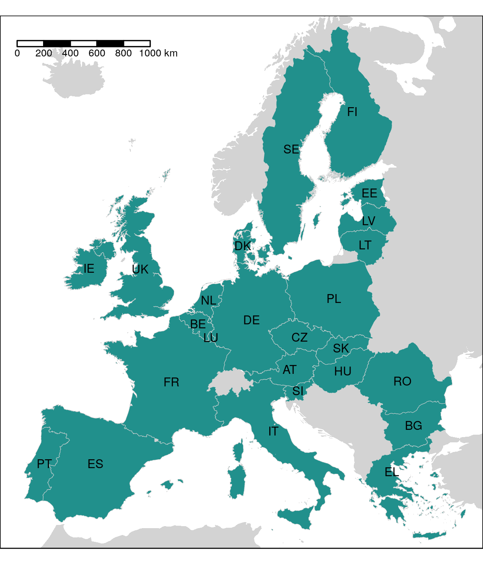

Figure 2.

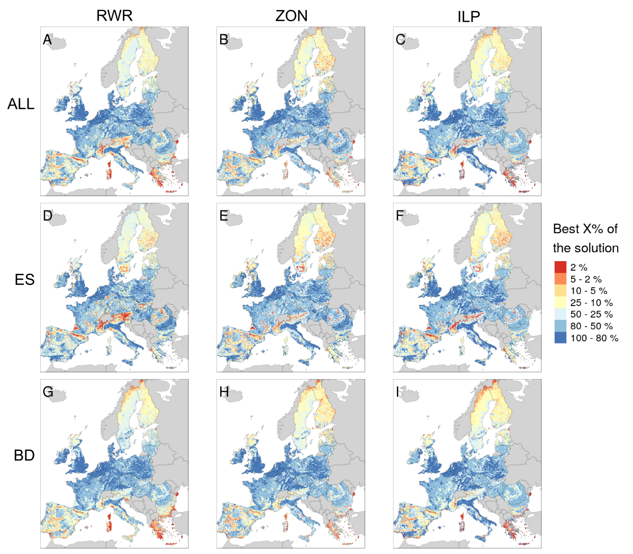

Figure 3.

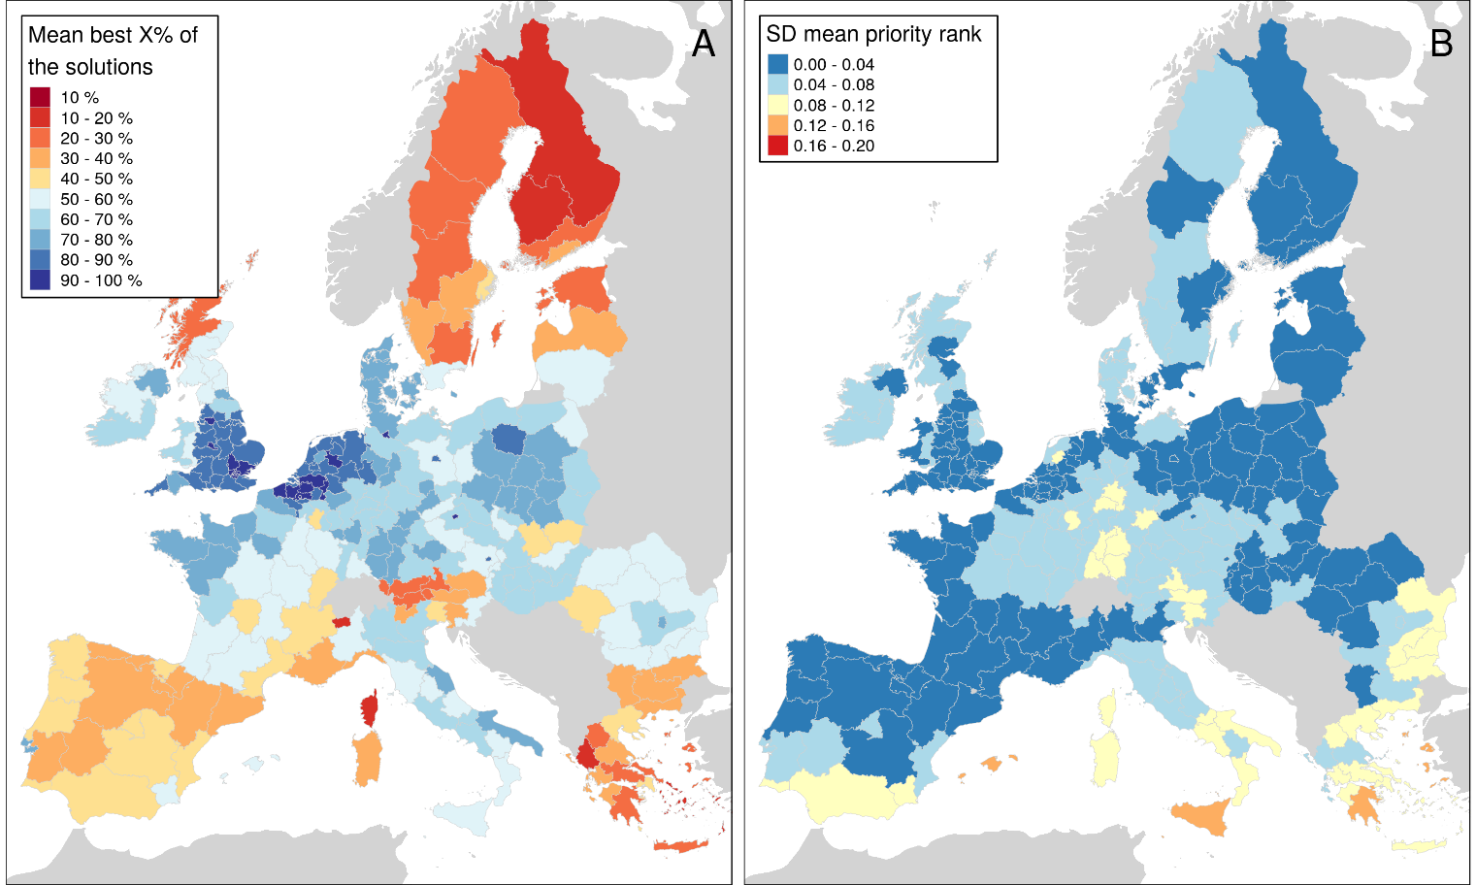

Figure 4.

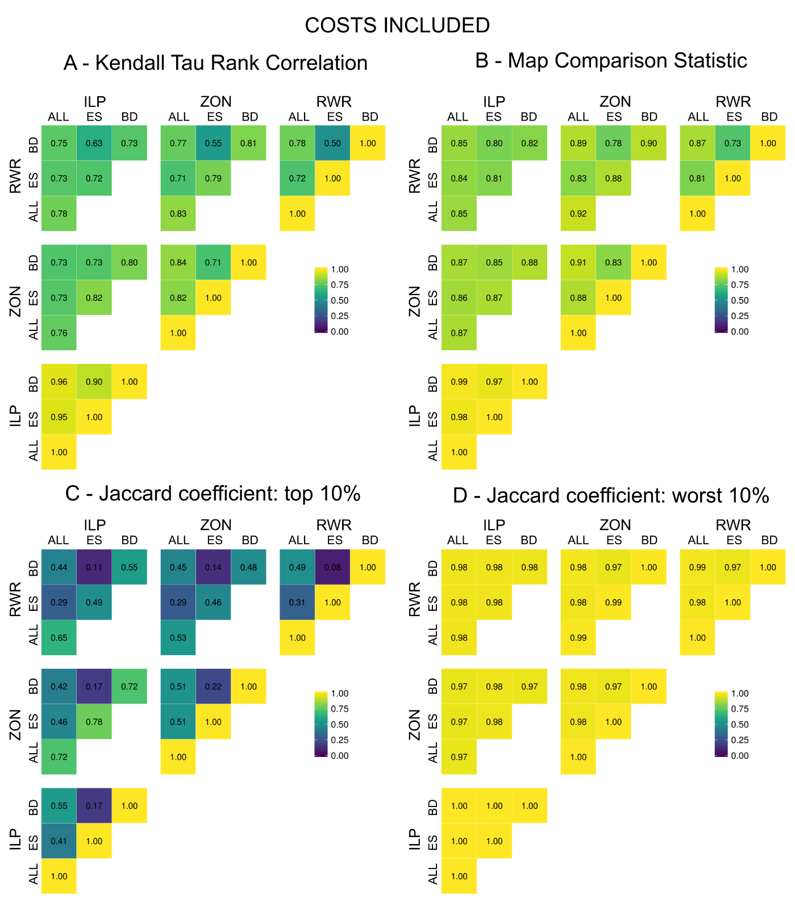

Figure 5.

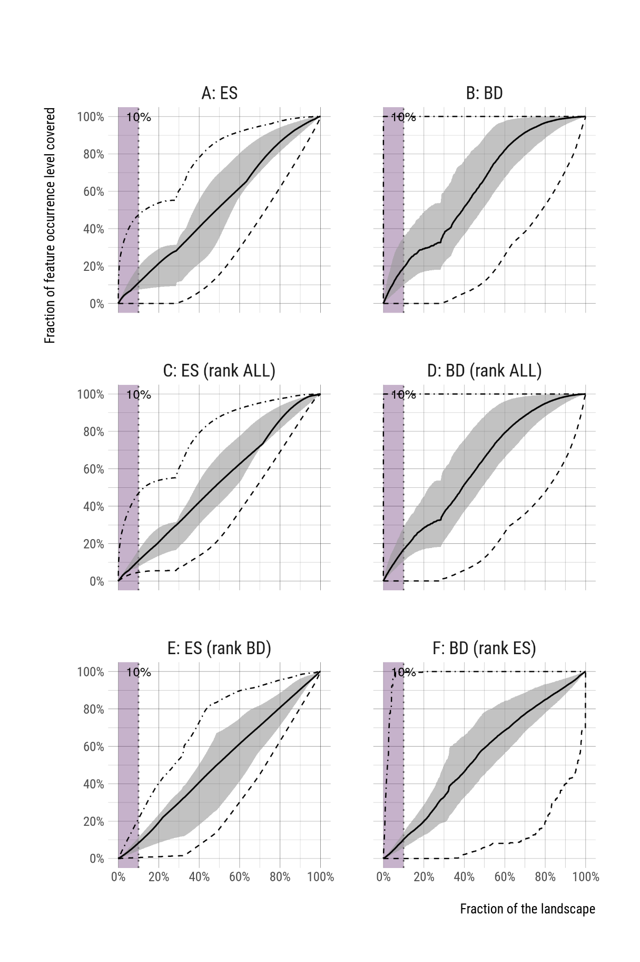

Figure 6.

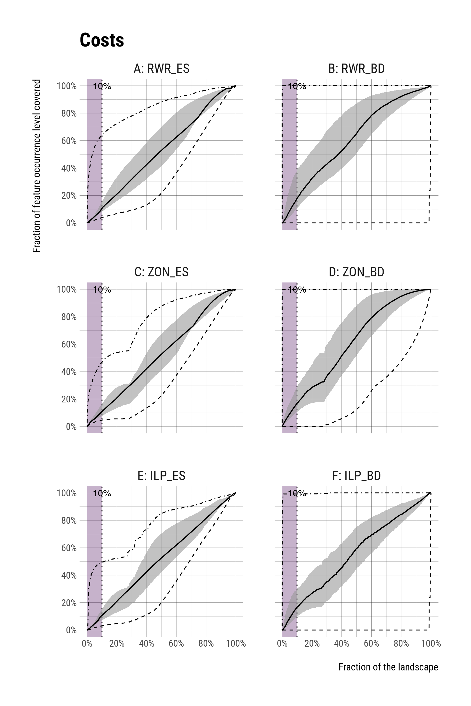

Figure S1.

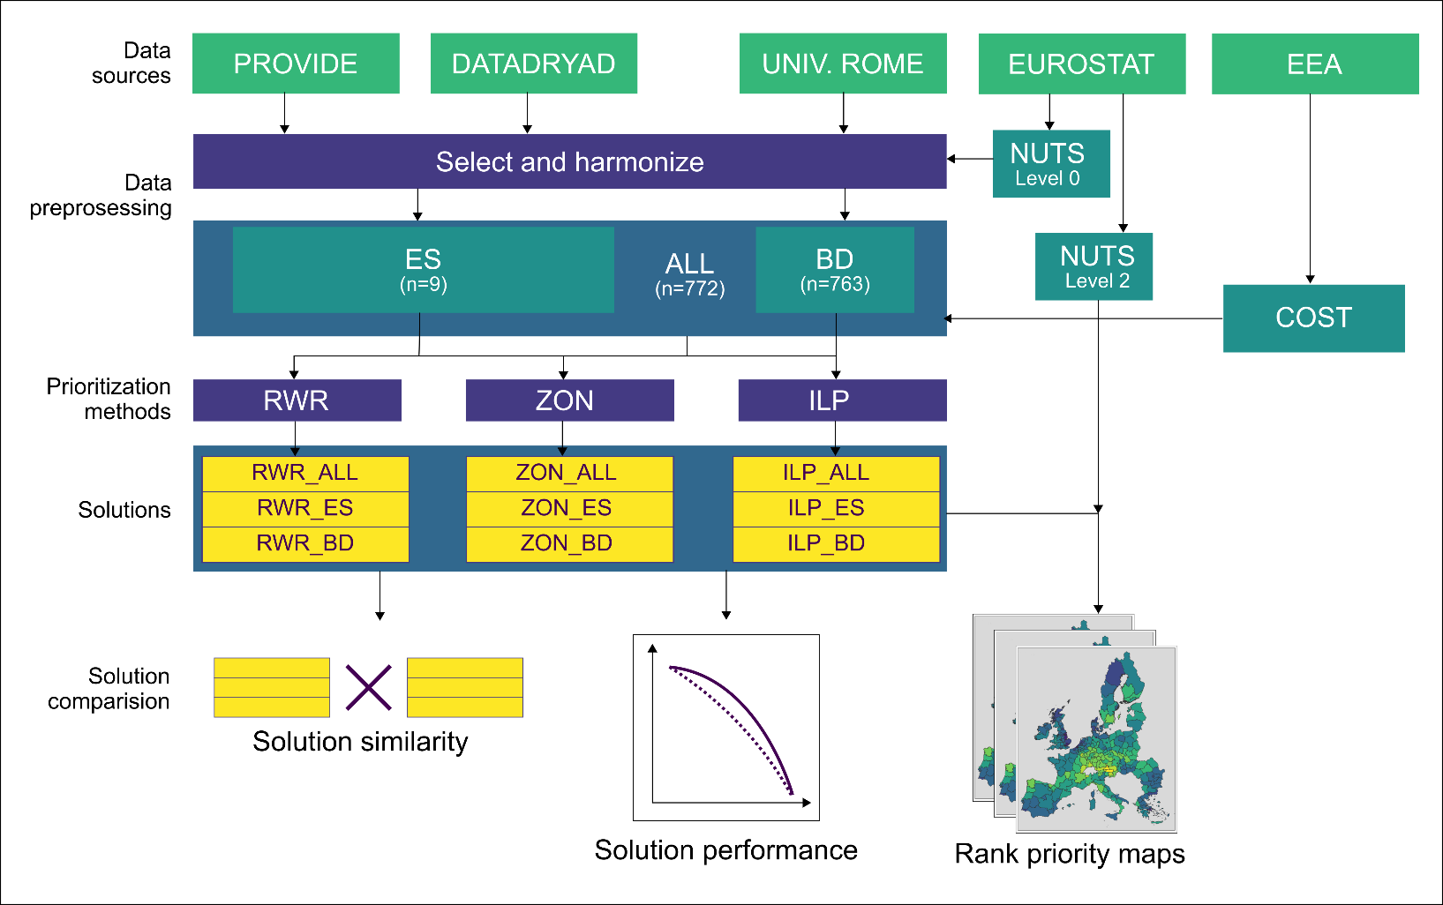

Figure S2.

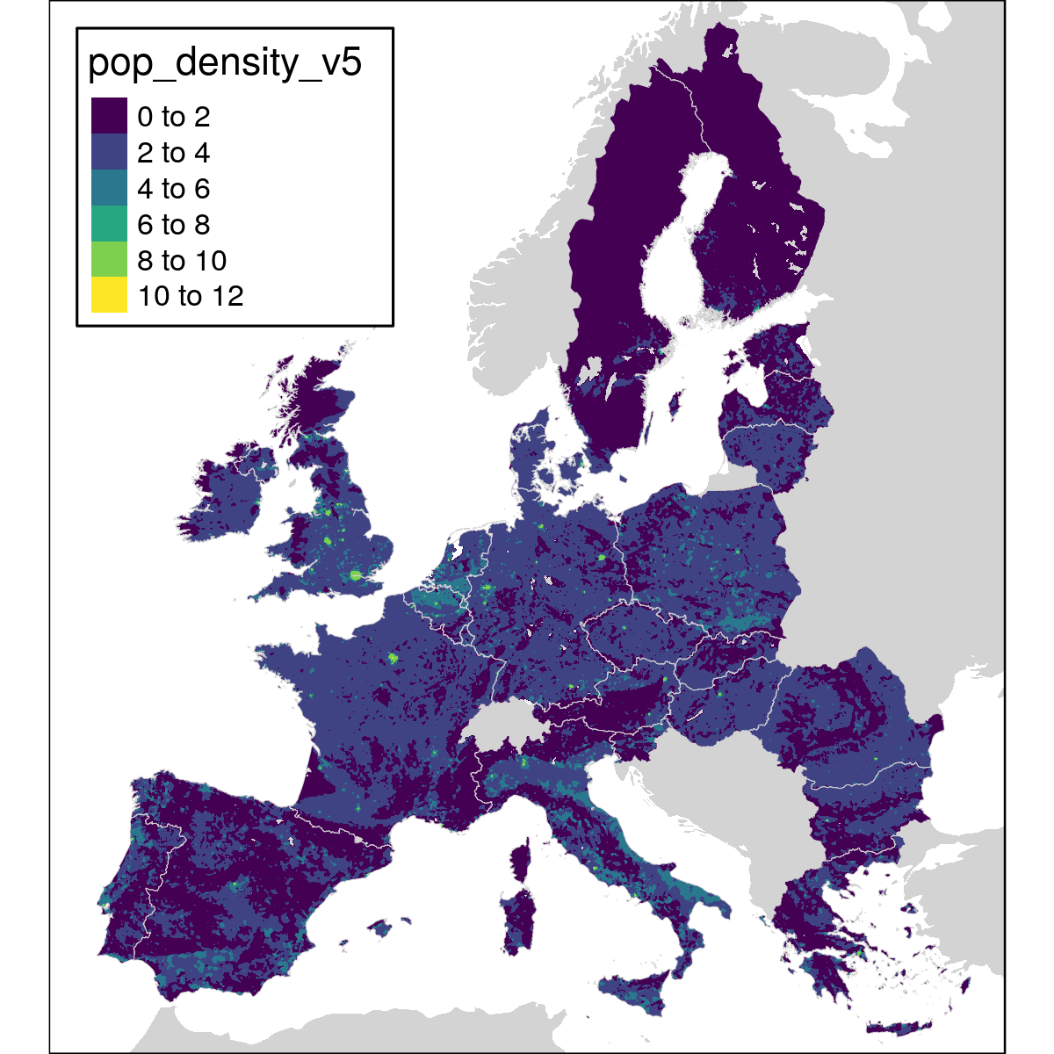

Cost index

Figure S3.

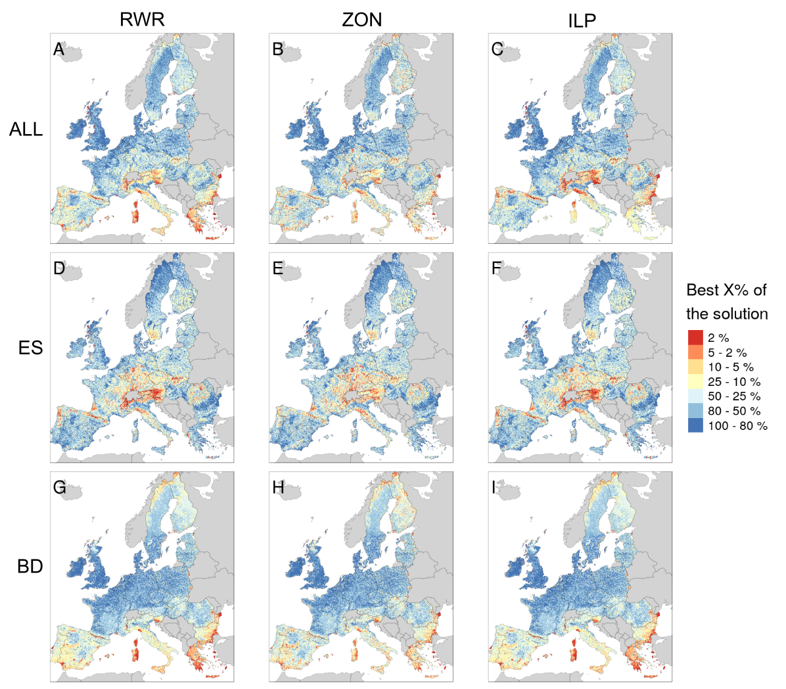

Figure S4.

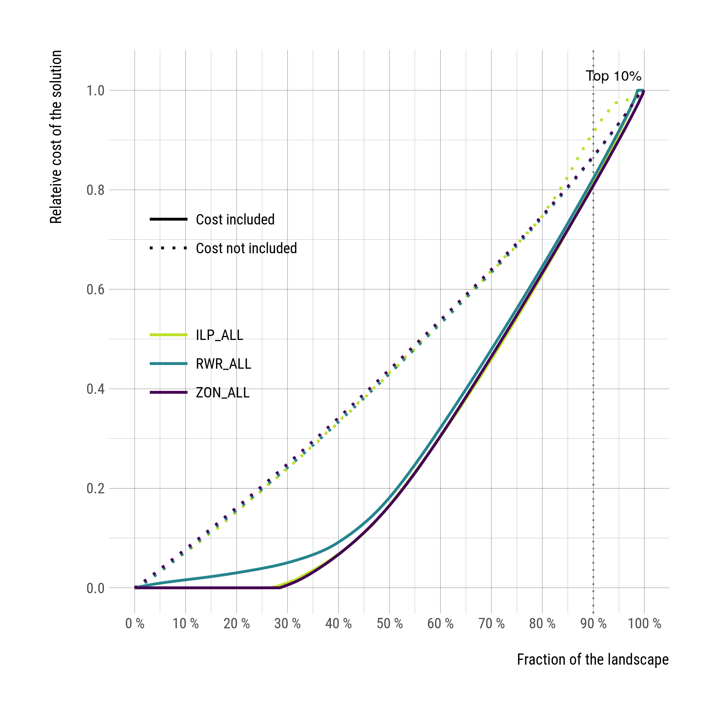o

# Tables

**Table 1.** Spatially explicit datasets used in the study.

**Dataset Group Description Unit Temporal Source  
 coverage**

**Ecosystem services**

Climate ES Response of terrestrial carbon Mg / C / ha 2006 Schulp et al.

regulation balance to land use change scenarios. ⁠ (2008)

Erosion ES Protection of land cover against Tonnes / ha 2000 – 2030 Pérez-Soba   
prevention erosion in erosion prone areas. et al. (2010)

Flood ES Water retention capacity. Index (relative flood flows) 2007 – 2011 Stürck et al.  
regulation regulation of land use and (2014)

soil on river high flows)

Heritage: ES A cultural heritage index that is used Index 2000 – 2015 Tieskens et al.  
agricultural to show the spatial distribution of (submitted)  
landscapes the overall cultural heritage index

scores in agricultural land.

Heritage: ES A cultural heritage index that is used Index 2000 – 2015 Tieskens et al.  
 to show the spatial distribution of (submitted)  
forests the overall cultural heritage index

scores in forests.

Pollination flows ES Unmanaged pollinators that live in Index (the ratio between 2000 Serna-Chavez

suitable natural and semi-natural the proportion of benefiting et al. (2014)

habitats provide pollination services areas located within the flow   
 especially to near croplands. area and the total benefiting

areas)

Tourism ES Supply of assets for tourism Index 1999-2009 Van Berkel et al.

supported by ecosystems. (2011)

Wild food ES Species richness of wild edible plants, Species richness of vascular 1999 – 2012 Schulp et al.   
provisioning mushrooms and game (supply) and plants (2014)

demand of wild food.

Wood ES High-resolution wood production 1000 m3 / pixel Average of Verkerk et al.  
production maps for European forests. 2000-2010 (2015)

**Biodiversity features**

European BD Species-specific expert-based Percentage of habitat in the 1997 – 2013 Thuiller et al

terrestrial distribution models for 164 mammal, cell (primary + non-primary (2015)

vertebrates 404 bird, 83 amphibian, and 112 habitat)

reptile species. See Table S1 for a

complete listing.

# Appendix

Table 2 Biodiversity features (n=759) used in the prioritization analyses.

|  |
| --- |
| **Amphibians** |
| Alytes cisternasii |
| Alytes dickhilleni |
| Alytes muletensis |
| Alytes obstetricans |
| Atylodes genei |
| Bombina bombina |
| Bombina pachypus |
| Bombina variegata |
| Bufo bufo |
| Calotriton arnoldi |
| Calotriton asper |
| Chioglossa lusitanica |
| Discoglossus galganoi |
| Discoglossus jeanneae |
| Discoglossus montalentii |
| Discoglossus pictus |
| Discoglossus sardus |
| Epidalea calamita |
| Euproctus montanus |
| Euproctus platycephalus |
| Hyla arborea |
| Hyla intermedia |
| Hyla meridionalis |
| Hyla sarda |
| Lissotriton boscai |
| Lissotriton helveticus |
| Lissotriton italicus |
| Lissotriton montandoni |
| Lissotriton vulgaris |
| Lyciasalamandra helverseni |
| Lyciasalamandra luschani |
| Mesotriton alpestris |
| Pelobates cultripes |
| Pelobates fuscus |
| Pelobates syriacus |
| Pelodytes ibericus |
| Pelodytes punctatus |
| Pelophylax bedriagae |
| Pelophylax bergeri |
| Pelophylax cerigensis |
| Pelophylax cretensis |
| Pelophylax epeirotcus |
| Pelophylax esculentus |
| Pelophylax grafi |
| Pelophylax hispanicus |
| Pelophylax kurtmuelleri |
| Pelophylax lessonae |
| Pelophylax perezi |
| Pelophylax ridibundus |
| Pleurodeles waltl |
| Proteus anguinus |
| Pseudepidalea balearica |
| Pseudepidalea sicula |
| Pseudepidalea variabilis |
| Pseudepidalea viridis |
| Rana arvalis |
| Rana dalmatina |
| Rana graeca |
| Rana iberica |
| Rana italica |
| Rana latastei |
| Rana pyrenaica |
| Rana temporaria |
| Salamandra atra |
| Salamandra corsica |
| Salamandra lanzai |
| Salamandra salamandra |
| Salamandrina perspicillata |
| Salamandrina terdigitata |
| Speleomantes ambrosii |
| Speleomantes flavus |
| Speleomantes imperialis |
| Speleomantes italicus |
| Speleomantes sarrabusensis |
| Speleomantes strinatii |
| Speleomantes supramontis |
| Triturus carnifex |
| Triturus cristatus |
| Triturus dobrogicus |
| Triturus karelinii |
| Triturus macedonicus |
| Triturus marmoratus |
| Triturus pygmaeus  **Birds** |
| Accipiter brevipes |
| Acrocephalus agricola |
| Acrocephalus arundinaceus |
| Acrocephalus dumetorum |
| Acrocephalus melanopogon |
| Acrocephalus paludicola |
| Acrocephalus palustris |
| Acrocephalus schoenobaenus |
| Acrocephalus scirpaceus |
| Actitis hypoleucos |
| Aegithalos caudatus |
| Aegolius funereus |
| Aegypius monachus |
| Alauda arvensis |
| Alca torda |
| Alcedo atthis |
| Alectoris barbara |
| Alectoris chukar |
| Alectoris graeca |
| Alectoris rufa |
| Anas acuta |
| Anas clypeata |
| Anas crecca |
| Anas penelope |
| Anas platyrhynchos |
| Anas querquedula |
| Anas strepera |
| Anser anser |
| Anser brachyrhynchus |
| Anser erythropus |
| Anser fabalis |
| Anthus campestris |
| Anthus cervinus |
| Anthus petrosus |
| Anthus pratensis |
| Anthus spinoletta |
| Anthus trivialis |
| Apus apus |
| Apus caffer |
| Apus melba |
| Apus pallidus |
| Aquila adalberti |
| Aquila chrysaetos |
| Aquila clanga |
| Aquila heliaca |
| Aquila pomarina |
| Ardea cinerea |
| Ardea purpurea |
| Ardeola ralloides |
| Arenaria interpres |
| Asio flammeus |
| Asio otus |
| Athene noctua |
| Aythya ferina |
| Aythya fuligula |
| Aythya marila |
| Aythya nyroca |
| Bombycilla garrulus |
| Bonasa bonasia |
| Botaurus stellaris |
| Branta bernicla |
| Branta leucopsis |
| Bubo bubo |
| Bubulcus ibis |
| Bucanetes githagineus |
| Bucephala clangula |
| Burhinus oedicnemus |
| Buteo buteo |
| Buteo lagopus |
| Buteo rufinus |
| Calandrella brachydactyla |
| Calandrella rufescens |
| Calcarius lapponicus |
| Calidris canutus |
| Calidris maritima |
| Calidris minuta |
| Calidris temminckii |
| Calonectris diomedea |
| Caprimulgus europaeus |
| Caprimulgus ruficollis |
| Carduelis cannabina |
| Carduelis carduelis |
| Carduelis chloris |
| Carduelis flammea |
| Carduelis flavirostris |
| Carduelis hornemanni |
| Carduelis spinus |
| Carpodacus erythrinus |
| Cepphus grylle |
| Cercotrichas galactote |
| Certhia familiaris |
| Cettia cetti |
| Charadrius alexandrinus |
| Charadrius dubius |
| Charadrius hiaticula |
| Charadrius morinellus |
| Chersophilus duponti |
| Chlidonias hybridus |
| Chlidonias leucopterus |
| Chlidonias niger |
| Ciconia ciconia |
| Ciconia nigra |
| Cinclus cinclus |
| Circaetus gallicus |
| Circus aeruginosus |
| Circus cyaneus |
| Circus macrourus |
| Circus pygargus |
| Cisticola juncidis |
| Clamator glandarius |
| Clangula hyemalis |
| Coccothraustes coccothraustes |
| Columba livia |
| Columba oenas |
| Coracias garrulus |
| Corvus corax |
| Corvus corone |
| Corvus frugilegus |
| Corvus monedula |
| Coturnix coturnix |
| Crex crex |
| Cuculus canorus |
| Cuculus saturatus |
| Cyanopica cyana cyanus |
| Cygnus cygnus |
| Cygnus olor |
| Delichon urbica |
| Dendrocopos leucotos |
| Dendrocopos major |
| Dendrocopos medius |
| Dendrocopos minor |
| Dendrocopos syriacus |
| Dryocopus martius |
| Egretta alba |
| Egretta garzetta |
| Elanus caeruleus |
| Emberiza aureola |
| Emberiza caesia |
| Emberiza cia |
| Emberiza cineracea |
| Emberiza cirlus |
| Emberiza citrinella |
| Emberiza hortulana |
| Emberiza melanocephala |
| Emberiza pusilla |
| Emberiza rustica |
| Emberiza schoeniclus |
| Eremophila alpestris |
| Erithacus rubecula |
| Falco biarmicus |
| Falco cherrug |
| Falco columbarius |
| Falco eleonorae |
| Falco naumanni |
| Falco peregrinus |
| Falco rusticolus |
| Falco subbuteo |
| Falco tinnunculus |
| Falco vespertinus |
| Ficedula albicollis |
| Ficedula hypoleuca |
| Ficedula parva |
| Ficedula semitorquata |
| Fratercula arctica |
| Fringilla montifringilla |
| Fulica atra |
| Fulica cristata |
| Fulmarus glacialis |
| Galerida cristata |
| Galerida theklae |
| Gallinago gallinago |
| Gallinago media |
| Gallinula chloropus |
| Garrulus glandarius |
| Gavia arctica |
| Gavia immer |
| Gavia stellata |
| Gelochelidon nilotica |
| Glareola nordmanni |
| Glareola pratincola |
| Glaucidium passerinum |
| Grus grus |
| Gypaetus barbatus |
| Gyps fulvus |
| Haematopus ostralegus |
| Halcyon smyrnensis |
| Haliaeetus albicilla |
| Hieraaetus fasciatus |
| Hieraaetus pennatus |
| Himantopus himantopus |
| Hippolais icterina |
| Hippolais olivetorum |
| Hippolais pallida |
| Hippolais polyglotta |
| Hirundo daurica |
| Hirundo rustica |
| Hoplopterus spinosus |
| Hydrobates pelagicus |
| Ixobrychus minutus |
| Jynx torquilla |
| Lagopus lagopus |
| Lagopus mutus |
| Lanius collurio |
| Lanius excubitor |
| Lanius meridionalis |
| Lanius minor |
| Lanius nubicus |
| Lanius senator |
| Larus argentatus |
| Larus audouinii |
| Larus cachinnans |
| Larus canus |
| Larus fuscus |
| Larus genei |
| Larus marinus |
| Larus melanocephalus |
| Larus minutus |
| Larus ridibundus |
| Limicola falcinellus |
| Limosa lapponica |
| Limosa limosa |
| Locustella fluviatilis |
| Locustella luscinioides |
| Locustella naevia |
| Loxia curvirostra |
| Loxia leucoptera |
| Loxia pytyopsittacus |
| Loxia scotica |
| Lullula arborea |
| Luscinia luscinia |
| Luscinia megarhynchos |
| Luscinia svecica |
| Lymnocryptes minimus |
| Marmaronetta angustirostris |
| Melanitta fusca |
| Melanitta nigra |
| Melanocorypha calandra |
| Mergus albellus |
| Mergus merganser |
| Mergus serrator |
| Merops apiaster |
| Miliaria calandra |
| Milvus migrans |
| Milvus milvus |
| Monticola saxatilis |
| Monticola solitarius |
| Montifringilla nivalis |
| Morus bassanus |
| Motacilla alba |
| Motacilla cinerea |
| Motacilla citreola |
| Motacilla flava |
| Muscicapa striata |
| Neophron percnopterus |
| Netta rufina |
| Nucifraga caryocatactes |
| Numenius arquata |
| Numenius phaeopus |
| Nyctea scandiaca |
| Nycticorax nycticorax |
| Oceanodroma castro |
| Oceanodroma leucorhoa |
| Oenanthe hispanica |
| Oenanthe isabellina |
| Oenanthe leucura |
| Oenanthe oenanthe |
| Oenanthe pleschanka |
| Oriolus oriolus |
| Otis tarda |
| Otus scops |
| Oxyura leucocephala |
| Pandion haliaetus |
| Panurus biarmicus |
| Parus caeruleus |
| Parus cinctus |
| Parus cristatus |
| Parus lugubris |
| Parus major |
| Parus montanus |
| Parus palustris |
| Passer domesticus |
| Passer hispaniolensis |
| Passer italiae |
| Passer montanus |
| Pelecanus crispus |
| Pelecanus onocrotalus |
| Perisoreus infaustus |
| Pernis apivorus |
| Petronia petronia |
| Phalaropus lobatus |
| Phalocrocorax carbo |
| Phalocrocorax pygmaeus |
| Phasianus colchicus |
| Philomachus pugnax |
| Phoenicopterus roseus |
| Phoenicurus ochruros |
| Phoenicurus phoenicurus |
| Phylloscopus bonelli |
| Phylloscopus borealis |
| Phylloscopus collybita |
| Phylloscopus sibilatrix |
| Phylloscopus trochiloides |
| Phylloscopus trochilus |
| Pica pica |
| Picoides tridactylus |
| Picus canus |
| Picus viridis |
| Pinicola enucleator |
| Platalea leucorodia |
| Plectrophenax nivalis |
| Plegadis falcinellus |
| Pluvialis apricaria |
| Podiceps auritus |
| Podiceps cristatus |
| Podiceps grisegena |
| Podiceps nigricollis |
| Porphyrio porphyrio |
| Porzana parva |
| Porzana porzana |
| Porzana pusilla |
| Prunella collaris |
| Prunella modularis |
| Pterocles alchata |
| Pterocles orientalis |
| Ptyonoprogne rupestris |
| Puffinus mauretanicus |
| Puffinus puffinus |
| Puffinus yelkouan |
| Pyrrhocorax graculus |
| Pyrrhocorax pyrrhocorax |
| Pyrrhula pyrrhula |
| Rallus aquaticus |
| Recurvirostra avosetta |
| Regulus ignicapillus |
| Regulus regulus |
| Remiz pendulinus |
| Riparia riparia |
| Rissa tridactyla |
| Saxicola rubetra |
| Saxicola torquata |
| Scolopax rusticola |
| Serinus citrinella |
| Serinus serinus |
| Sitta europaea |
| Sitta krueperi |
| Sitta neumayer |
| Sitta whiteheadi |
| Somateria mollissima |
| Stercorarius longicaudus |
| Stercorarius parasiticus |
| Stercorarius skua |
| Sterna albifrons |
| Sterna bengalensis |
| Sterna caspia |
| Sterna dougallii |
| Sterna hirundo |
| Sterna paradisaea |
| Sterna sandvicensis |
| Streptopelia decaocto |
| Streptopelia turtur |
| Strix aluco |
| Strix nebulosa |
| Strix uralensis |
| Sturnus roseus |
| Sturnus unicolor |
| Sturnus vulgaris |
| Surnia ulula |
| Sylvia atricapilla |
| Sylvia borin |
| Sylvia cantillans |
| Sylvia communis |
| Sylvia conspicillata |
| Sylvia curruca |
| Sylvia hortensis |
| Sylvia melanocephala |
| Sylvia nisoria |
| Sylvia rueppelli |
| Sylvia sarda |
| Sylvia undata |
| Tachybaptus ruficollis |
| Tadorna ferruginea |
| Tadorna tadorna |
| Tarsiger cyanurus |
| Tetrao urogallus |
| Tetrax tetrax |
| Tichodroma muraria |
| Tringa erythropus |
| Tringa glareola |
| Tringa nebularia |
| Tringa ochropus |
| Tringa stagnatilis |
| Tringa totanus |
| Turdus iliacus |
| Turdus merula |
| Turdus philomelos |
| Turdus pilaris |
| Turdus torquatus |
| Turdus viscivorus |
| Turnix sylvatica |
| Tyto alba |
| Upupa epops |
| Uria lomvia |
| Vanellus vanellus |
| Xenus cinereus |
| **Mammals** |
| Acomys minous |
| Alces alces |
| Alopex lagopus |
| Apodemus agrarius |
| Apodemus alpicola |
| Apodemus epimelas |
| Apodemus flavicollis |
| Apodemus mystacinus |
| Apodemus sylvaticus |
| Apodemus uralensis |
| Apodemus witherbyi |
| Arvicola amphibius |
| Arvicola sapidus |
| Arvicola scherman |
| Atelerix algirus |
| Barbastella barbastellus |
| Bison bonasus |
| Canis aureus |
| Capra ibex |
| Capra pyrenaica |
| Capreolus capreolus |
| Chionomys nivalis |
| Cricetulus migratorius |
| Cricetus cricetus |
| Crocidura leucodon |
| Crocidura pachyura |
| Crocidura russula |
| Crocidura sicula |
| Crocidura suaveolens |
| Crocidura zimmermanni |
| Dama dama |
| Dinaromys bogdanovi |
| Dryomys nitedula |
| Eliomys quercinus |
| Eptesicus bottae |
| Eptesicus nilsonii |
| Eptesicus serotinus |
| Erinaceus europaeus |
| Erinaceus roumanicus |
| Felis silvestris |
| Galemys pyrenaicus |
| Genetta genetta |
| Glis glis |
| Gulo gulo |
| Hystrix cristata |
| Lemmus lemmus |
| Lepus capensis |
| Lepus castroviejoi |
| Lepus corsicanus |
| Lepus europaeus |
| Lepus granatensis |
| Lepus timidus |
| Lutra lutra |
| Lynx pardinus |
| Martes foina |
| Martes martes |
| Meles meles |
| Meriones tristami |
| Mesocricetus newtoni |
| Micromys minutus |
| Microtus agrestis |
| Microtus arvalis |
| Microtus bavaricus |
| Microtus brachycercus |
| Microtus cabrerae |
| Microtus duodecimcostatus |
| Microtus felteni |
| Microtus gerbei |
| Microtus guentheri |
| Microtus levis |
| Microtus liechtesteini |
| Microtus lusitanicus |
| Microtus multiplex |
| Microtus oeconomus |
| Microtus savii |
| Microtus subterraneus |
| Microtus tatricus |
| Microtus thomasi |
| Miniopterus schreibersi |
| Mus macedonicus |
| Mus musculus |
| Mus spicilegus |
| Mus spretus |
| Muscardinus avellanarius |
| Mustela erminea |
| Mustela eversmanii |
| Mustela lutreola |
| Mustela nivalis |
| Mustela putorius |
| Myodes glareolus |
| Myodes rufocanus |
| Myodes rutilus |
| Myomimus roachi |
| Myopus schisticolor |
| Myotis alcathoe |
| Myotis aurascens |
| Myotis bechsteinii |
| Myotis blythii |
| Myotis brandtii |
| Myotis capaccinii |
| Myotis dasycneme |
| Myotis daubentonii |
| Myotis emarginatus |
| Myotis myotis |
| Myotis mystacinus |
| Myotis nattereri |
| Myotis punicus |
| Neomys anomalus |
| Neomys fodiens |
| Nyctalus lasiopterus |
| Nyctalus leisleri |
| Nyctalus noctula |
| Oryctolagus cuniculus |
| Ovis aries |
| Pipistrellus kuhlii |
| Pipistrellus nathusii |
| Pipistrellus pipistrellus |
| Pipistrellus pygmaeus |
| Pipistrellus savii |
| Plecotus auritus |
| Plecotus austriacus |
| Plecotus kolombatovici |
| Plecotus macrobullaris |
| Plecotus sardus |
| Pteromys volans |
| Rhinolophus blasii |
| Rhinolophus euryale |
| Rhinolophus ferrumequinum |
| Rhinolophus hipposideros |
| Rhinolophus mehelyi |
| Rupicapra rupicapra |
| Sciurus anomalus |
| Sciurus vulgaris |
| Sicista betulina |
| Sicista severtzovi |
| Sicista subtilis |
| Sorex alpinus |
| Sorex antinorii |
| Sorex araneus |
| Sorex caecutiens |
| Sorex coronatus |
| Sorex granarius |
| Sorex isodon |
| Sorex minutissimus |
| Sorex minutus |
| Sorex samniticus |
| Spalax graecus |
| Spalax leucodon |
| Spalax nehringi |
| Spermophilus citellus |
| Spermophilus suslicus |
| Suncus etruscus |
| Sus scrofa |
| Tadarida teniotis |
| Talpa caeca |
| Talpa europaea |
| Talpa levantis |
| Talpa occidentalis |
| Talpa romana |
| Talpa stankovici |
| Ursus arctos |
| Vespertilio murinus |
| Vormela peregusna |
| Vulpes vulpes |
| Ablepharus kitaibelii |
| Acanthodactylus erythrurus |
| **Reptiles** |
| Algyroides fitzingeri |
| Algyroides marchi |
| Algyroides moreoticus |
| Algyroides nigropunctatus |
| Anatolacerta anatolica |
| Anatolacerta oertzeni |
| Anguis cephallonica |
| Anguis fragilis |
| Archaeolacerta bedriagae |
| Blanus cinereus |
| Blanus strauchi |
| Chalcides bedriagai |
| Chalcides chalcides |
| Chalcides ocellatus |
| Chalcides striatus |
| Chamaeleo africanus |
| Chamaeleo chamaeleon |
| Coronella austriaca |
| Coronella girondica |
| Cyrtopodion kotschyi |
| Darevskia praticola |
| Dolichophis caspius |
| Dolichophis jugularis |
| Eirenis modestus |
| Elaphe quatuorlineata |
| Elaphe sauromates |
| Emys orbicularis |
| Emys trinacris |
| Eremias arguta |
| Eryx jaculus |
| Euleptes europaea |
| Eumeces schneideri |
| Hellenolacerta graeca |
| Hemidactylus turcicus |
| Hemorrhois hippocrepis |
| Hemorrhois nummifer |
| Hierophis gemonensis |
| Hierophis gyarosensis |
| Hierophis viridiflavus |
| Iberolacerta aranica |
| Iberolacerta aurelioi |
| Iberolacerta bonnali |
| Iberolacerta cyreni |
| Iberolacerta galani |
| Iberolacerta horvathi |
| Iberolacerta martinezricai |
| Iberolacerta monticola |
| Lacerta agilis |
| Lacerta bilineata |
| Lacerta schreiberi |
| Lacerta trilineata |
| Lacerta viridis |
| Laudakia stellio |
| Macroprotodon brevis |
| Macroprotodon cucullatus |
| Macroprotodon mauritanicus |
| Macrovipera schweizeri |
| Malpolon monspessulanus |
| Mauremys leprosa |
| Mauremys rivulata |
| Montivipera xanthina |
| Natrix maura |
| Natrix tesselleta |
| Ophiomorus punctatissimus |
| Ophisops elegans |
| Parvilacerta parva |
| Platyceps collaris |
| Platyceps najadum |
| Podarcis bocagei |
| Podarcis carbonelli |
| Podarcis erhardii |
| Podarcis filfolensis |
| Podarcis gaigeae |
| Podarcis hispanica |
| Podarcis lilfordi |
| Podarcis melisellensis |
| Podarcis milensis |
| Podarcis muralis |
| Podarcis peloponnesiaca |
| Podarcis pityusensis |
| Podarcis raffonei |
| Podarcis sicula |
| Podarcis taurica |
| Podarcis tiliguerta |
| Podarcis vaucheri |
| Podarcis wagleriana |
| Psammodromus hispanicus |
| Psammodromus jeanneae |
| Psammodromus manuelae |
| Pseudopus apodus |
| Rhinechis scalaris |
| Tarentola mauritanica |
| Telescopus fallax |
| Testudo graeca |
| Testudo hermanni |
| Testudo marginata |
| Timon lepidus |
| Trachylepis aurata |
| Trionyx triunguis |
| Typhlops vermicularis |
| Vipera ammodytes |
| Vipera aspis |
| Vipera berus |
| Vipera latastei |
| Vipera renardi |
| Vipera seoanei |
| Vipera ursinii |
| Zamenis lineatus |
| Zamenis longissimus |
| Zamenis situla |
|  |
|  |